Epileptic Monitoring Device
Senior Project I
November 2013
Team:
Mark Curran, Rachel Kolb (Team Leader), Kevin Pineda, & Timothy Skinner
Advisors:
Dr.BuSha (BME) & Dr. Adegbege (ELC)

Abstract
Epilepsy is a brain disorder that affects millions of adults and children in America. It is characterized by abnormal neuronal signaling and can cause strange sensations, emotions, behavior, loss of consciousness, muscle spasms and convulsions. These episodes are very difficult to predict with the current technologies available, and almost impossible to accurately record outside clinical settings. This project aims to create an ambulatory device that can measure long-term electroencephalography (EEG) outside of a hospital. The Epileptic Monitoring Device (EMD) is a portable device with two separate units: a head-mounted EEG recording system and a data viewing application on an Android platform. The EEG is recorded using five electrodes in referential montage attached to a headset and passes the signal through an isolation amplifier and then into a microcontroller for analog-to-digital conversion. The digital signal is sent via Bluetooth transceiver to the mobile device where it is processed and viewed using the Android application. An alarm will be triggered when the application detects seizure-like activity. The EMD will provide accurate monitoring for epileptic patients within the comfort of day-to-day activities. Caretakers and medical professionals can use this data to determine types of seizures, number of seizures, and the efficacy of medication.

Individual Abstracts:
  - Mark Curran:
Nearly every electronic device today is driven by an embedded system. Whether browsing the Internet on a personal computer or playing games on a mobile device, microprocessors on these embedded systems make these functions happen. Computer programming is the key ingredient for embedded systems to do their job. There are numerous computer programming languages today, such as C, C++, Ruby, Python, and Java. Using an Arduino board to communicate with an Android tablet via Bluetooth, will allow a patient to monitor their EEG activity on their Android device running Android 4.4 (KitKat).
  - Rachel Kolb:
EEG is a crucial tool to diagnose epilepsy and can be done using as few as a single electrode or as many as 256 or more electrodes. The number of electrodes as well as the arrangement provides an understanding of where the epileptic activity originates from within the brain. Ambulatory EEG is used to monitor individuals with epilepsy and test for epilepsy, by providing continuous monitoring within a clinical setting. The EMD will have four gold cup electrodes arranged in a referential montage to record long-term EEG.
  - Kevin Pineda:
The headset is one of the main components of the EMD that will be used to house and support five electrodes, store wiring and circuit components, and to fit comfortably on the user’s head for an extended period of time. The design was chosen based on feasibility, reliability, comfort, manufacturability, and aesthetics. The headset was designed using Solidworks and will be through the use of the Objet30 Pro 3D printer using VeroBlue as the material. The headset will be printed in several parts, which include the headpiece, three supports, and their respective bottom attachments to allow for easy access and installation for the wires of the EEG electrodes.
  - Timothy Skinner:
The characterization of the epileptic seizure signals and signal processing of the device requires background knowledge and research into digital signal processing, communication systems, and RF devices. Digital signal processing is the mathematical manipulation of signal information to modify the signal in some way. This is usually characterized with discrete time or discrete frequency representation. Digital signal processing will be used to characterize finite epileptic seizure signals. Communication systems and RF devices are utilized when sending signals via Bluetooth, and amplifying the EEG signals. This will be an important portion of the project that that will determine the successfulness of the Epileptic Monitoring Device.

Key Words:
Medical signal detection | Medical signal processing | Neurophysiology | Signal classification | Diseases | Electroencephalography | Epilepsy | Epileptic seizures | EEG signal analysis | Brain disorders | Epileptic EEG signals | Fast Fourier Transform

Table of Contents
Abstract 2
Individual Abstracts: 2
Key Words: 3
List of Figures 5
Nomenclature 5
Introduction 7
Team management 8
Overall Design Specifications 10
Chapter 1: Background 13
Chapter 2: Electrodes 14
Chapter 3: Signal Processing 23
Chapter 4: Microcontroller 29
Chapter 5: Android Application 30
Chapter 6: Headset 31
Chapter 7: Conclusion 44
Appendix 45
Team Members 45
Engineering Standards 46
Realistic Constraints 47
Engineering Tools 50
Ethical Concerns 51
IRB 51
Gantt chart 52
Materials List 54
Project Budget 55
Business Plan 55
Citations 57

List of Figures

Figure 1: International 10-20 Electrode System Diagram (http://eegatlas-online.com/index.php/montages) 16
Figure 2: Electrode cap arrangement using 256 electrodes 18
Figure 3: Comparison of electrode types and their frequency readings 20
Figure 4: Different cup electrode materials 22
Figure 6: Non Inverting Operational Amplifier 23
Figure 7: Completed design circuit 24
Figure 8: Non-epileptic EEG signal recorded with the Emotiv 27
Figure 9: Epileptic EEG signal graphed using MatLab 28
Figure 10 Examples of designs used for EEG recording: cap, headset, headband, and standard electrode configuration 32
Figure 11 Material properties for VeroBlue 33
Figure 12 Solidworks drawing and isometric view of the first headset prototype. 35
Figure 13 Bottom attachment for the headset and supports, respectively. 35
Figure 14 Slot mechanism for the bottom attachment of the headset. 35
Figure 15 Solidworks assembly of first headset prototype with a human head model. 36
Figure 16 3D printed out first headset prototype headpiece and support with assembly. 37
Figure 17 First prototype headpiece on team member Kevin Pineda. 38
Figure 18 Final headpiece design with dimensions on the left picture and an isometric view on the right picture. 39
Figure 19 Final headset support designs. The left support is for the left and right part of the headpiece while the right support is for the back part of the headpiece. 40
Figure 20 Solidworks assembly of final headset prototype on a human head model with electrodes. 41
Figure 21 Solidworks exploded assembly of final headset design on human head model (left). Close up view of slot mechanism of the support and headpiece (right). 41
Figure 22 Stress analysis test on final design headpiece using 60N force at the inner sides. 42
Figure 23 Stress analysis test on final design support using 10 N force applied at the bottom 43
Figure 24: Table of engineering tools used for the EMD 50
Figure 25: Gantt chart close-up of time-line 52
Figure 26: Gantt chart overview of timeline 53
Figure 27 Materials list for the EMD 54
Figure 28: EMD Budget Overview 55

Nomenclature
EEG: Electroencephalography – measures the electrical activity of the brain
EMD: Epileptic Monitoring Device – device which monitors epileptic activity in the brain
Hz: Hertz – measure of frequency, the number per cycles per second in a periodic artifact.
MHz: Mega Hertz
GHz: Giga Hertz
V: Volts – measure of electric potential difference
μV: Microvolts
R: Resistor – measure of the opposition of electric current through a conductor
R1, R2, R3, R4 and RF are specific resistors in a diagram
dB: Decibel – unit used to express the ratio between two physical quantities, often power or amplitude, used to determine gain.
A: Ampere – measure of electrical current
mA: milliamps
Mbps: Megabytes per second – measure of data transfer rate
FFT: Fast Fourier Transform – algorithm to compute discrete Fourier transform, which converts signals from their original domain to the frequency domain.
Op-Amp: Operational Amplifier – integrated circuits used to build filters and amplifiers
Ah: Ampere hour – unit of electrical charge
mAh: milliampere hour
FTDI: Future Technology Devices International -
PWM: Pulse Width Modulation – Technique that conforms the width of the pulse based on modulator signal
IDE: Integrated development environment – Coding environment
kB: Kilobytes – measure of digital information
ADC: Analog to Digital Converter – device that converts a continuous physical input to a discrete quantity output to represent the physical input.
KSPS: Kilo Samples Per Second – sampling rate used for ADC
DC: Direct Current – unidirectional flow of electrical charge, found in batteries
I/O: Input/Output
API: Application Programming Interface – Libraries which come with operating system, specifies software component interaction

Introduction
Epilepsy is a neurological disorder, which is characterized by sudden, recurrent episodes of sensory disturbance caused by abnormal electrical activity in the brain. These disturbances can take the form of loss of consciousness and convulsions. Nearly 3 million Americans are diagnosed with epilepsy and manage it with drug therapy or surgery. A key diagnostic tool for epilepsy is EEG, a test that measures the voltage fluctuations along the scalp from ionic current due to neuronal activity. Epileptic seizures are extremely difficult to predict and can be tricky to accurately record. It is also extremely difficult for caretakers to constantly monitor the epileptic patient. In order to resolve this issue, an ambulatory EMD will alert the caregiver at seizure onset and record and store EEG recordings. The device will be portable, cost-effective, and designed for daily use at home. The EMD will feature five electrodes, which will record the EEG from the patient. The signal will be sent through an isolation amplifier and low-pass filter to a microcontroller for analog to digital conversion, powered by a polymer lithium ion battery. The digital signal will be transferred from the microcontroller to the android tablet running the application by a Bluetooth transceiver. The android application will record and store the epileptic EEG readings as well as notify the caregiver.

Team management
In order to meet our design objectives we have divided the different aspects of the design to different individuals based on their interests and educational backgrounds.
Mark
With a background in computer engineering and an interest in android applications, Mark will be responsible for the microcontroller and android application. His responsibilities include coding for both the microcontroller and android application, implementing the EEG characterization parameters established by Rachel and Tim, selecting an android tablet, and selecting a microcontroller.
Rachel
As the team leader, Rachel will be responsible for general project management, which includes: maintaining progress and updating the Gantt chart accordingly, ordering parts, managing the team budget, taking meeting minutes, updating progress blog on website, compiling reports, and ensuring quality standards for all project related work. She will also be responsible for anything electrode related such as type of electrode, type of conductive materials used, electrode placement along the scalp, electrode and headset interaction, electrode montaging, and electrode connection to the device. She will also be working alongside Tim on characterization of EEG signals and analysis of electrode connection and signal strength. Rachel and Kevin will be responsible for completing the Internal Review Board submission to test the device on members of the group.
Kevin
As a biomedical engineer with a specialization in mechanical engineering, Kevin will be responsible for designing the headset. His headset design takes into account the following considerations: aesthetic of the overall design, space for electrical components and power source on the headset, alignment of electrodes, and strength necessary to keep the electrodes in place. Majority of the headset will be made utilizing the 3D printer and he will be responsible for creating and printing the headset design in SolidWorks and associated material and design testing. Kevin and Rachel will be responsible for completing the Internal Review Board submission to test the device on members of the group.
Tim
With a background in electrical engineering, Tim will be responsible for the signal processing and power source for the device. For signal processing Tim will be in charge of selecting an isolation amplifier, designing the low-pass filter, selecting a power source, signal transferring via Bluetooth transceiver, and selecting a Bluetooth transceiver. He will also be working alongside Rachel on characterization of EEG signals and analysis of electrode connection and signal strength. Tim also designed and formatted the team website and continuously updates it with new design information.

Overall Design Specifications
Design Input | Design Specifications | Verification Activity | Validation Activity
Lightweight headset | Weight < 1 kg | Approximate the weight of the headset and all design components | Headset will be weighed with all parts attached
Headset incorporates circuitry | Insert Standard Breadboard Size | Headset is modeled in SolidWorks with compartments for electrodes, wires, batteries, and breadboard with circuit design using approximate measurements for components | Headset assembly will have all electrical components hidden
Comfortable headset | Headset design based on: average head breadth of 14.5 cm, average menton of 24.1 cm, average bizygomatic breadth of 13.9 cm. | Headset is designed according to specifications in SolidWorksi without sharp edges | Headset does not cause pain or discomfort to user
Aesthetic design headset | Headset protrudes a maximum of 5 cm from point of contact | Headset modeled with Solidworksi with human head model to ensure good fit and minimal protrustion | Headset look will be evaluated by peers
Headset manufactured by Objet30 Pro Printer | Net build size: 294 x 192 x 148.6 mm (11.57 x 7.55 x 5.85 in)  Layer thickness: 28 microns (0.0011 in.); 16 microns for VeroClear material (0.0006 in.)  Accuracy: 0.1 mm (0.0039 in.) may vary depending on part geometry, size, orientation, material and post-processing method | Meet with 3D printer operators to ensure compatibility | Headset is able to be printed according to specified dimensions
Headset needs to house electrodes | Needs to hold 5 electrodes in their specific locations | Solidworksi design assembly with 5 electrodes in their distinct locations based upon 10-20 international system | Headset worn is able to support all five electrodes when worn on the head and during daily use
Few number of electrodes | Less than 21 electrodes | Research has been done using 4 electrodes to measure EEG | EMD EEG readings are consistent with Emotiv readings
Few number of channels displayed | Less than 16 channels | Research has been done using 4 channels for epilepsy EEG management | EMD EEG readings are consistent with Emotiv readings
Application needs to accurately display EEG signals | 323 pixels per inch, 1920x1200 HD display | Android 4.4 has graphing tools in API | Graph of EEG from EMD is similar to Emotiv reading graph
Microcontroller needs to convert analog to digital accurately | ADC has a sampling frequency minimum of 120 Hz | Studying the datasheet of the microprocessor | Comparing the EMD readings to that of the Emotiv EPOC
Application needs to run on a recent Android platform | Android 4.4 (KitKat) | Android 4.4 is compatible with Nexus 7 | Check tablet to ensure application runs properly
EEG recorded data needs to be user accessible | Data must be stored on internal memory | Coding to store data | Check memory of tablet to ensure data is present
Application needs to connect via Bluetooth | 41 mAh, 2.1Mbps, 2.4 GHz frequency range | Datasheets provided to view before purchase | All information is sent from arduino to android app
Application signals alert when epileptic seizure activity is detected | Alert is triggered by defined “abnormal” eeg signals | Android 4.4 has a compare and contrast library in API | If frequency is passed then alert is triggered
Amplify the signal from the electrodes to the microcontroller | Two amplifiers in series with enough gain to amplify the signal | Using Pspice to model different circuits | Purchase and assemble the circuit and test using oscilloscope
Remove noise from electrode signal | Active Low Pass Filter Circuit | Model in Pspice | Purchase and assemble the circuit. Test using oscilloscope
Electrodes and user need to be isolated from the power source | Isolation Amplifier | Research into reliable bio amplifiers | Test using multimeter to see if there is any current passing through
Android Application must differentiate between epileptic and non-epileptic EEG | Java code for Fast Fourier Transform of pre recorded epileptic signals | Test using Matlab | Send the information to the tablet from the computer
Long-term battery life | Greater than 8 hours | 850mAh divided by approximately 100mAh used by the circuit schematic, android and Bluetooth | Once assembled, keep it running for as long as possible before needing to be recharged

Chapter 1: Background
Epileptic seizures are almost impossible to trace once it has passed without the use of EEG devices. Because of this, physicians are unable to confirm that a patient has had a seizure without the necessary equipment. As a result, patients who experience epileptic seizures require constant attention from caretakers and physicians. In a hospital, patients undergo a lengthy process for attaching numerous EEG electrodes, which are secured using a conductive paste. They are then required to stay in place for an extended period of time while a doctor monitors their brain. This can be very uncomfortable to the patient. Usually, the doctor treats the patients with anticonvulsants and allows them to go home after treatment. The epileptic monitoring device serves to make sure that the treatment is working outside of a hospital setting by measuring EEG signals and triggering an alarm once there is seizure-like EEG activity to a caretaker or physician.
The EMD is comprised of two main components, the headset with electrodes and an Android tablet to effectively record and display EEG signals from a patient. The headset was designed based on current EEG ambulatory devices on the market for overall comfort over an extended period of time and effective way to support the EEG electrodes, wiring, and circuit components. Gold plated EEG electrodes are used because they were found to be the best reusable electrodes due to low resistance, high frequency noise, low baseline drift, and more stable. Five electrodes were chosen for the device based on successful research done on EEG readings with less than five electrodes. The EEG signals recorded from the electrodes pass through an isolation amplifier and a low-pass filter. The amplifier is used to increase the power of the EEG signal because EEG signals are relatively weak, only having readings of around 500-1500 µV. Filtering the signal is necessary for getting rid of noise, which can either physical or physiological. Examples of physical noise include general body movement and electronic equipment such as computers, phones, and routers in the environment. Examples of physiological noise include cardiac signals, muscle contraction, and eye movement. The signal then goes through a microcontroller for analog to digital conversion. This is done because Android software is only compatible to use with digital signals. The microcontroller transfers the digital signals to the Nexus 7 Android tablet via Bluetooth to characterize, display, and store the EEG signals. The Nexus 7 Android tablet was chosen because it has more than enough power to process EEG signals and excellent battery life, which is essential for using the EMD in the long term. The newest version was chosen because it is future proof since it gets updates directly from Google, which will make the device more efficient and effective over time. Bluetooth is used because it is wireless, inexpensive, automatic, and has low interference and energy consumption.

Chapter 2: Electrodes
The number of electrodes used for EEG is directly related to the spatial resolution of cortical potential distribution, or electrical impulses in the brain. The number of electrodes necessary is dependent on the function of the EEG, current epilepsy research includes seizure detection using EEG, which requires more accurate localization compared to EEG readings to diagnose epilepsy. There have been current studies, which have successfully recorded EEG using only four electrodes.
For epilepsy the clinically relevant EEG frequency band is 0.1 to 100 Hz and amplitudes measured along the scalp tend to range between 10 to 100 μV. The amplitude recorded can also vary based on electrode location. There can also be other relevant EEG frequency bands dependent on the type of seizure. The electrical impulses that EEG records are from the postsynaptic potentials in the dendrites of large pyramidal neurons. When multiple neurons active simultaneously a dipole moment is created and can be measured. For epileptic individuals these dipoles can also be created from other stimuli such as, sensory, motor or cognitive.
The 10-20 International System is the standard for recording EEG from the scalp, seen in Figure 1.
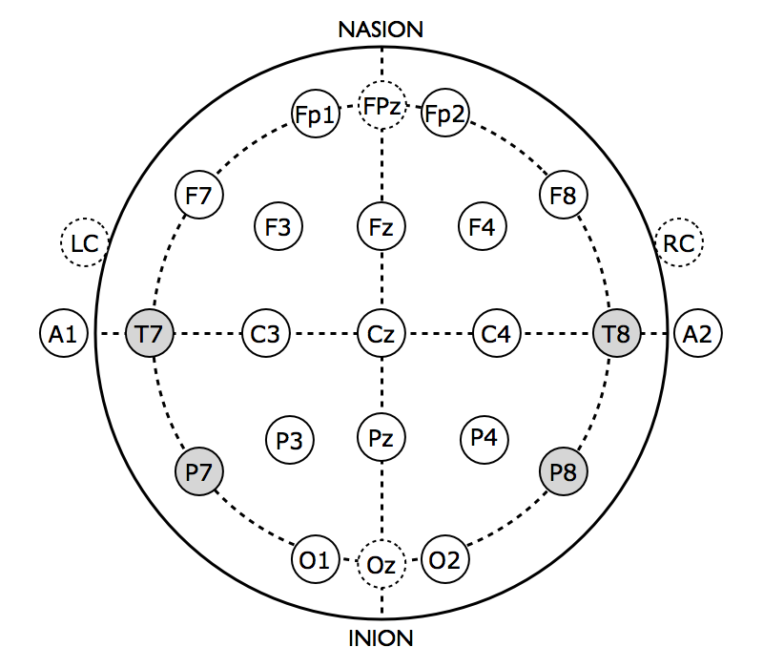
Figure 1: International 10-20 Electrode System Diagram
The 10-20 System uses 21 electrodes arranged at 10% and 20% intervals along four reference points: the inion, nasion, along with the left and right preauricular. Other electrode arrangement systems have been derived based upon the 10-20 International System using more electrodes, such as the 10-10 system and 10-5 system, both of which use more than 21 electrodes. Some of these systems place the electrodes in a cap based upon a specific electrode arrangement system, visible in Figure 2.
The electrodes will be placed at T7, C3, Cz, C4, and T8. These locations have been chosen because they span the width of the head and are spaced equidistant. The EMD is not trying to precisely locate the origin of the electrical impulse. The electrodes will be arranged in a referential montage, similar to that of the Emotiv EPOC device. The reference electrode will be located at Cz because it is centrally located between the naison, inion, as well as left and right preauricular and will not be subject to asymmetric electrical impulse propagation from the brain. This establishes that point as a zero.
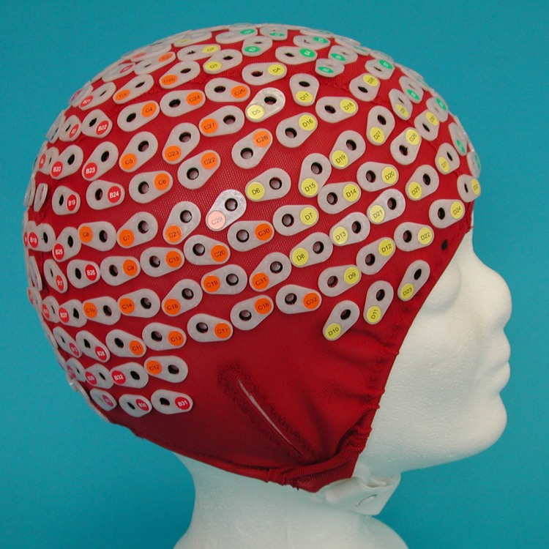
Figure 2: Electrode cap arrangement using 256 electrodes
The EEG signals recorded from the brain can vary due to many different factors including type of activity and frequency band. The EEG signals are also affected due to the volume conductor effects within the brain. Volume conductor effects take into account that the signal conductivity within the brain is not linear because the skull is not a spherical shape. The conductivity of the signal is nonlinear, partly due to the cerebrospinal fluid within the brain. The cerebrospinal fluid regions have conductivity, which is several times larger than that of other brain tissue. Other characteristics, which attribute to the nonlinearity are non-homogenous compartments within the brain, lesions within the brain, and some tissues are anisotropic or directionally dependent.
Aside from volume conductor effects, there are also other bio-electric activities occurring in the brain which can manifest on EEG. These activities include eye movement, blinking, muscle activity, and cardiac activity. There also can be outside noise which can interfere with an accurate EEG recording. There is also an inherent resistivity from the skull and scalp. A standard value of this resistivity is 1:80:1 between the brain, skull and scalp respectively.
Electrodes are designed to be reusable or disposable, because the EMD will be used daily it will use reusable electrodes. By choosing reusable electrodes, the user will not need to constantly replace electrodes or have to reattach and remove electrodes to the headset after each use.
There are two forms of electrodes commercially available: wet or dry. Wet electrodes use conductive paste or liquid to enhance the clarity of the signal. Dry electrodes do not use any conductive paste or liquid and have a dry conductive surface. The dry electrodes do not require any prep to the site of electrode attachment and achieve excellent signal quality. As seen in Figure 3 the EEG readings from dry electrodes have a higher frequency resolution than that for wet electrodes.
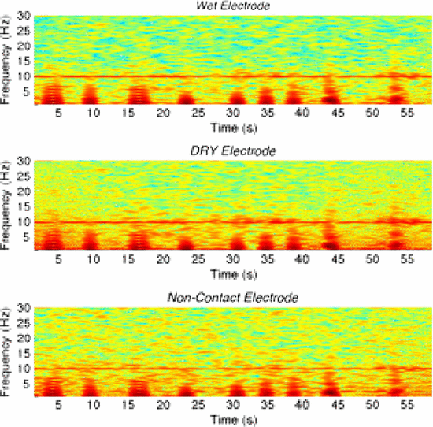
Figure 3: Comparison of electrode types and their frequency readings
Although electrodes are better suited for the EMD compared to wet electrodes, they are not as commercially available. G Tec is a medical engineering company which specializes in dry electrodes and makes the g.Sahara electrode which is a dry electrode system. G Tec quoted that g.Sahara electrode costs over $1000, for the EMD system using 5 electrodes for the headset they are well outside of the project budget. Due to the restrictions for obtaining dry electrodes, the EMD will use wet electrodes and use an electrode sensor system similar to that of the Emotiv EPOC headset. The Emotiv EPOC headset has a felt piece, which attaches to the gold electrodes attached to the headset. The felt attachment allows the conductive saline solution to be absorbed and leaves less residue compared to traditional wet electrodes.
Wet electrodes are widely available in two different shapes: a cup disc and a flat disc. The geometry of the cup disc electrode allows for the conductive material to remain in contact with the electrode better than that of a flat disc electrode. The Emotiv EPOC also uses cup disc electrodes for the headset. Therefore in order for the EMD results to be comparable to the Emotiv EPOC, Figure 4, results for non-epileptic EEG readings they should feature closely related electrode systems.
Typically electrodes are made of silver chloride, AgCl, and feature a coating of gold, silver, platinum, or tin is common (https://wiki.engr.illinois.edu/display/BIOE414/EEG). See Figure 4 for the different cup electrodes. Standard electrodes are typically silver electrodes or gold plated silver electrodes. The EMD will use gold plated silver electrodes similar to those used in the Emotiv EPOC headset.
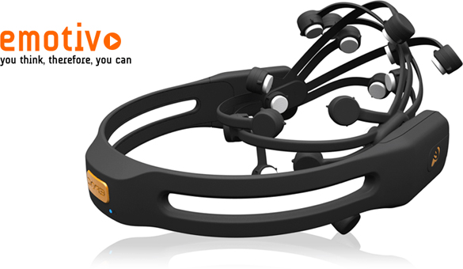
Figure 4: Emotiv EPOC headset
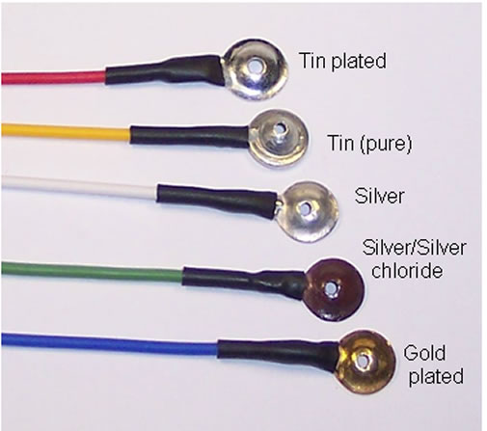
Figure 5: Different cup electrode materials

Chapter 3: Signal Processing
The signal-processing portion of the EMD will need to amplify EEG signals from microvolts to millivolts, cut off any high, unwarranted frequencies, send the signals via Bluetooth, and characterize as seizure like, non-determinant, or non-epileptic.
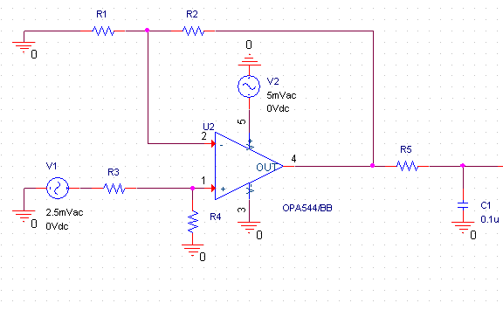
The amplification will be done using a bioinstrumentation amplifier with isolation to block any reflective voltage from the battery source that might go into the electrodes. The circuit will be a Non-Inverting Op-Amp Level Shifter, which will perform voltage level shifting to ensure that there are no negative values when the Arduino Pro Mini is performing analog to digital conversion. Any negative voltage values will not be sampled by the microprocessor.
Figure 6: Non Inverting Operational Amplifier
The equation, A = (R4/R1) x (R1+R2)/(R3+R4), can be used to determine the gain, or conversely the values of the resistors. If R3 = R1 and R2 = R4, then the gain will be equal to R4/R1. This means that the values of R4 and R2 will need to be significantly higher than R3 and R1 in order to obtain a high enough gain.
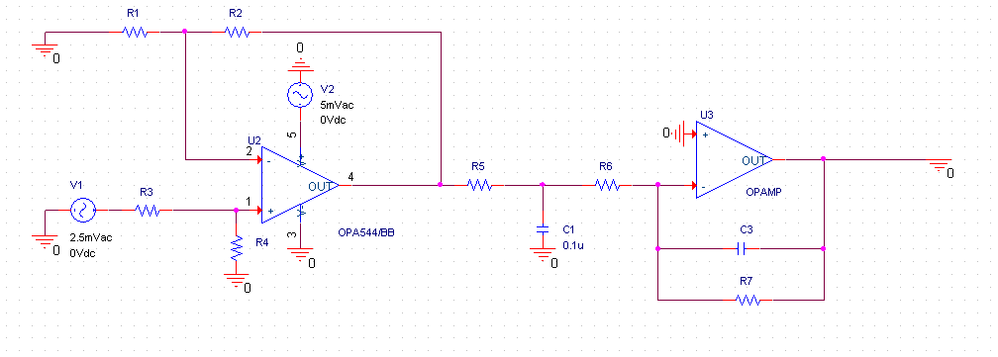
In series with this circuit will be an active low pass filter that will perform amplification and low pass filtering. The filter is designed to cutoff any unwanted frequencies. The Epileptic Monitoring Device will sample frequencies at 125Hz to obtain accurate EEG signals. Analyzing the low pass filter using the Laplace Transform, gives the transfer function V_{out}(S)/V_{in}(S) = (-R₂ /R₁ ) / sR₂C +1. Making R₂ greater than R₁ will increase the gain of the circuit, whereas the denominator provides the characteristics for the low pass filter.
Figure 7: Completed design circuit
Attached to the Arduino Pro Mini will be the Arduino Wireless Bluetooth Transceiver Module. This module will be the bridge between the Arduino board and Android Tablet. Several considerations were used when deciding between Bluetooth, WiFi, and RF Transceivers. Primarily, we wanted a low power-consuming device that would be easy to connect an arduino with a tablet. Even though the cost for RF transceivers would be low, they would have been complicated to set up with the android tablet. Both Wifi and Bluetooth come standard with a tablet, but the Bluetooth Module uses considerably less power than Wifi. Our Bluetooth Module uses only 35mA to pair and 8mA to send the data. This also provides the option to attach a Bluetooth dongle to a computer and have information be sent there when testing. The module sends a maximum of 2.1 Mbps, and operates at a frequency of 2.4 GHz.
The characterization of the EEG signals will be done by the android application. An android phone or tablet has better processing performances than the Arduino Pro Mini board, and can be charged with greater ease than the device. In order to characterize the signals, several different epileptic EEG signals were downloaded from the Internet and graphed using MatLab.
Non- epileptic EEG signals were obtained using the Emotiv EPOC Neuroheadset, a high resolution, neuro-signal acquisition and processing wireless neuroheadset. The Emotiv headset features 14 saline sensors, a lithium battery for continuous use, and features a wireless USB dongle. The EPOC also utilizes sequential sampling, at a rate of 128 samples per second, or 2048 Hz, it also samples from the following points from the 10-20 International system: AF3, F7, F3, FC5, T7, P7, O1, O2, P8, T8, FC6, F4, F8, AF4.
There are several defining characteristics when determining seizure like signals. There could be an increase in amplitude or frequency, or the left-sided signal might not match the right-sided signal. However, there have been articles published that discuss how a spike lasting longer than 5-10 seconds in the 5 Hz range is an indication of seizure like activity
Using the FFT to analyze normal and epileptic signals, the device will be able to characterize seizure like signals based on the spikes lasting longer than 5 seconds. The graph returns the discrete Fourier transform (DFT) of vector x, computed with a fast Fourier transform (FFT) algorithm. The FFT equation is defined as:
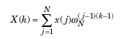
Where x(j) <=====> X(k)
With the Emotiv, and information found online, the FFT was taken to determine if any visible differences could be noticed.
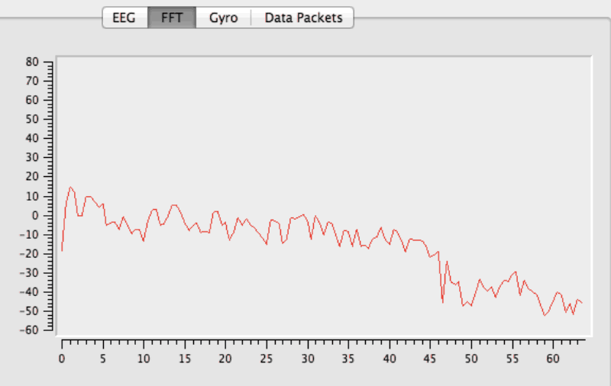
Figure 8: Non-epileptic EEG signal recorded with the Emotiv

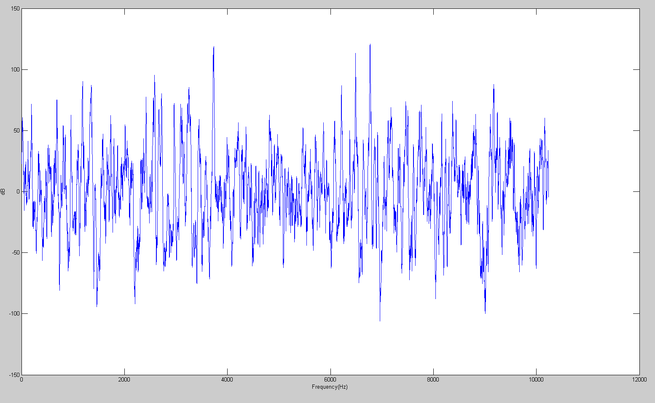
Figure 9: Epileptic EEG signal graphed using MatLab
Comparing Figure 3 and Figure 4, the graph never reaches 20dB around the 5 Hz range. The epileptic EEG signal, however, reaches above 50dB around that range. Initial testing for the FFT began with MatLab coding, but then had to be converted to Java in order to work on the android application.
The circuit and arduino board will need to be charged by a battery. The battery must meet several requirements in order to be long lasting, lightweight, and compact. The initial design had a 9V battery as the source. This was in the allotted 5-12V range at which the arduino ran, and was compact to fit in our headset. Unfortunately, the battery could not be recharged. This would lead to taking apart the headset in order to replace the battery. The next design was to use a rechargeable 9 V battery, but the weight was over 45 grams and the battery discharged only 350mAh. This would only provide a few hours between each charge. The EMD needs to be longer lasting to guarantee mobility.
Polymer lithium ion batteries will be used to meet the design specification. One polymer battery contains 3.7 volts, but attaching in series will yield 7.4 V falling in the 5-12 V range requirement for the arduino board. Together, the batteries weigh 37 grams (18.5 grams each) and have dimensions of 11.4x29.5x48.27mm. The batteries also discharge 850 mAh, which gives 8 hours before needing to be recharged. This value was determined by adding the mAh from the Bluetooth and arduino and dividing it from the mAh of the batteries.

Chapter 4: Microcontroller
The microcontroller that was chosen for the project was the Arduino Pro Mini. Arduino is an open-source electronics computing platform based on easy-to-use hardware and software. Its programming language is an implementation of Wiring, a similar open-source programming framework for microcontrollers, and while it's environment is based on Processing, a programming environment for multimedia. Programming the Arduino boards can be done in C or C++. The IDE allows for simple compilation and uploading of projects to the board. Though, an FTDI cable is needed to program the Pro Mini because it does not have a built in USB connection port.
The processor for the Pro Mini is the Atmel 328P. The Atmel 328P, from Atmel Corporation, provides 32 kB of flash memory and a max operating frequency of 20Mhz. It has an ADC with a 10 bit resolution at 15ksps. The Pro Mini board provides 14 digital input/output pins which 6 of those can be used as PWM, 8 analog inputs, an on-board resonator, a reset button, and holes for mounting pin headers. Operating voltage for the Pro Mini is at 5V with an input voltage between 5-12V. DC current for each I/O pin is 40mA.
Arduino was chosen for this project mainly because it is relatively inexpensive compared to other microcontrollers. Arduino is also cross-platform compatible, being able to run on Windows, Apple, and Linux computers. Most other microcontrollers are only limited to Windows operating systems. Arduino is open sourced, which is another favorable feature. This allows for a large supportive community willing to provide help to the most inexperienced designer. Tutorials are also provided on Arduino's website to further help designers. The Pro Mini was specifically selected because of its very small dimensions, 18x33mm. Having the Atmel 328P processor, the Pro Mini is a low power microcontroller that has an ADC that fulfills the needs of the project. The Pro Mini is also favorable because it has an over current and reverse polarity protector.

Chapter 5: Android Application
One of the requirements for the project was to use a smartphone application to display and store the EEG signals. An Android based operating system was decided to be used for the project. Android, a Linux based operating system, is an open source operating system developed and distributed by Google. Applications are download through Google's “Google Play” application. Currently, Android powers more than one billion phones and tablets.
One of the biggest questions that needed to be answered was which operating system to use, iOS or Android, to develop the application. According to market share numbers, Android beats iOS. Android has been making headway into the smartphone market but more activity has been reported for iOS. Android applications are primarily written in Java while iOS applications are primarily written in Objective C. Overall, the decision was made for Android simply because a preference was for Java coding and a dislike for iOS products.
Application development is going to be on Google's 2013 Nexus 7 running Android 4.4 (KitKat) operating system. The decision for the tablet was a cost decision. Buying an android phone off the Internet would result in two unfavorable options. The first option would be buying a phone without a contract, which would cost more than the tablet. The second option would be buying an unlocked phone that would be cheaper than the tablet, but would have an operating system that was not the most up-to-date. Android 4.4 (KitKat), level 19 API, was released by Google on October 31, 2013 and was built to optimize performance on devices with lower specifications. Also, the Nexus 7 has Bluetooth 4.0, which is optimize to be low power and remain paired or connected without requiring a continual stream of data to be transferred between devices.

Chapter 6: Headset

There are four main different types of designs used for EEG recording, two of which are suitable for ambulatory EEG devices.
They are the cap, headset^{xiii}, headband
, and the standard electrode configuration. Figure 5 shows an example of each of the four designs used in the market.
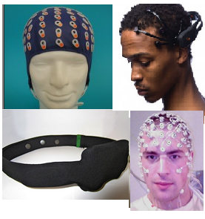
Figure 10 Examples of designs used for EEG recording: cap, headset, headband, and standard electrode configuration
The headset and headband designs are suitable for ambulatory EEG devices because they are designed for portability and comfort at the cost of meticulously detailed EEG readings. However, since the device only needs to determine that a seizure is occurring and not its origin of location, the headset and headband designs were the top two choices. Of the two, the EMD will feature a headset because it has more flexibility for electrode placement on the scalp and is more feasible to model and manufacture using Solidworksi and Objet30 Proiii 3D printer, respectively.
The goals of the headset are that it must support and house the electrodes in the referential montage across the scalp to record EEG data, incorporate and store the circuitry such as the wires, batteries, and breadboard, fit the head comfortably for an extended period of time, elastic enough to wrap around the head with ease, and have a simple assembly.
Solidworksi is being used to model the headset with the electrodes attached to the human head as closely as possible. A 3D printer was chosen to fabricate the headset because of its ability to print out models virtually exactly as designed and for its precise detail in designing aspects of the headset that would be very challenging to complete through machining. The material being used to print out the headset model is VeroBlue . Its material properties; can be seen in Figure 6. The printed headset will have a matte finish to be less prone to collecting dust.
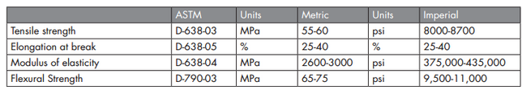
Figure 11 Material properties for VeroBlue
The points of contact for the headset include the back and the side of the head where the headpiece wraps around the side of the head. The rationale for this was to minimize the points of contact for maximum comfort for the user. There are two supports on either side of the head and one support at the back of the head that is designed to hold the EEG electrode wires. The supports for the five electrodes have a small hole for the wires to come out of for the electrode with the foam attached to be placed on the scalp at T3 C3 CZ C4 and T4 points from the 10-20 international system^{xiv}
The first prototype, as seen in Figure 7, shows the headset design along with dimensions taken in meters. The design was loosely based on the emotiv^{xiii} headset design in terms of the headpiece placement to the head. It is hollow on the inside for the circuitry components. There are bottom attachments for the headpiece and the supports shown in Figure 8 that slide in similar to a slot mechanism to allow for easy wire storage and because the 3D printer places support material in the hollow spaces since it prints in layers, which makes it extremely difficult to take out if it is completely enclosed. Figure 9 shows a close up view of the slot for the bottom attachment to show how it slides in. A thickness of .01 m was chosen based on the size of the wires for the electrical components and to be elastic enough to prevent any fractures. The dimensions of the average head, menton, and bizygomatic breadth are 14.5 cm, 24.1 cm, and 13.9 cm, respectively. However, because these measurements can considerably vary per individual, the headset was designed to fit fellow team member Kevin Pineda.
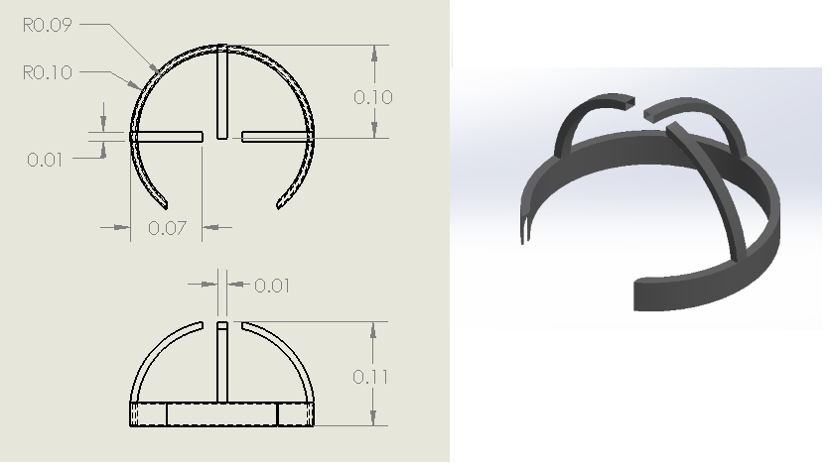
Figure 12 Solidworks drawing and isometric view of the first headset prototype.

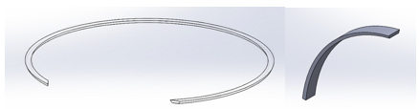
Figure 13 Bottom attachment for the headset and supports, respectively.
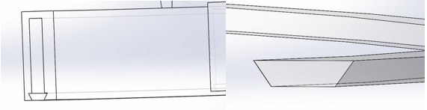
Figure 14 Slot mechanism for the bottom attachment of the headset.
Figure 10 shows a diametric view and a top view of a Solidworksi assembly of the headset on a human head model from Zygote Media Group to show how the electrodes and the headset are placed on the head.
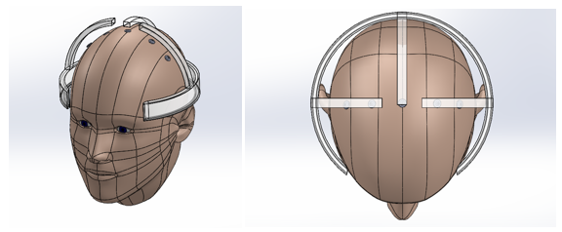
Figure 15 Solidworks assembly of first headset prototype with a human head model.
Originally, the headset was designed with both the headpiece and the supports as one piece. However, this would prove to be very costly to fabricate because the 3D printer would have to put a substantial amount of support material below the supports since it builds in layers. To alleviate this problem, it was decided that the headset was to be printed in different parts. Additionally, some space around was left around the head that is not in contact with the headpiece to incorporate a “cushion” that would be placed around the headpiece to enhance comfort in the long run.
Figure 11 shows the first headset prototype headpiece and one of the supports printed out in separate parts with an assembly of both parts. It cost around $80 to print the material. However, the cost for printing out the pieces were waived.
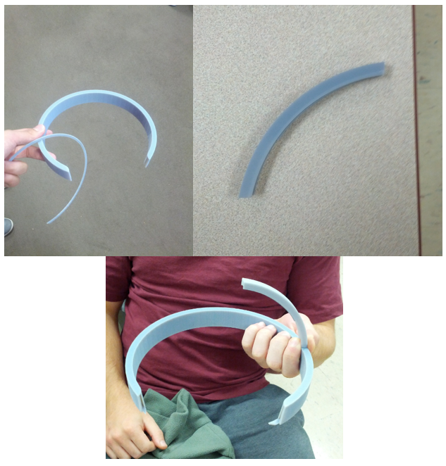
Figure 16 3D printed out first headset prototype headpiece and support with assembly.

Figure 12 shows the 3D printed headset prototype headpiece on top of fellow team member Kevin Pineda.

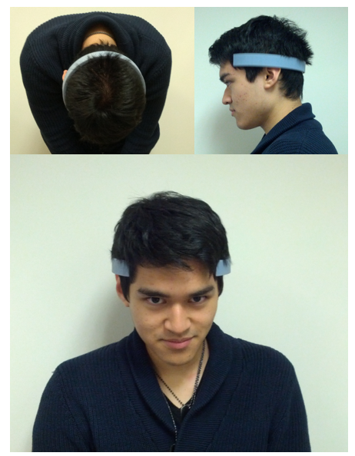
Figure 17 First prototype headpiece on team member Kevin Pineda.
Because there were no cushions along the sides of the head, the fitting of the headset was loose when placed upon team member Kevin. However, it was discovered that the VeroBlue material had a soft fuzzy texture to it that would be very comfortable to wear in the long term. This, along with a plan to build the headset in parts that could easily be assembled post 3D printing, lead to the final prototype design.
Figure 13 shows the redesigned headset piece with dimensions in meters. The final design improves upon the previous in that it is shaped like a horseshoe, which is how the human head is shaped when viewed from the top, to fit around the head without the need of cushions. Figure 14 shows the redesigned supports as separate parts. The supports have pegs that allow them to slide into the headpiece via a slot mechanism. Additional adhesives such as super glue can be utilized to permanently constrain the supports into place once the parts are 3D printed. There are also three .01 m diameter holes at the back of the headset for the wires from the EEG electrodes to connect through to a compartment containing the electrical components such as the Arduino pro board mini, breadboard, and battery. The casing is planned to be purchased from McMaster Carr to attach to back of the headset.

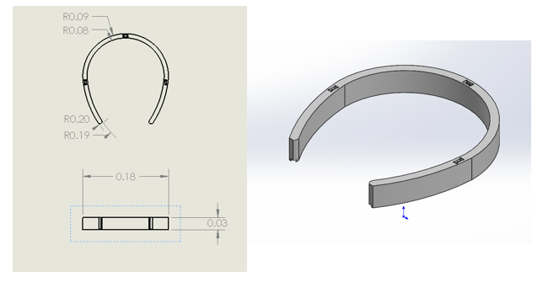
Figure 18 Final headpiece design with dimensions on the left picture and an isometric view on the right picture.
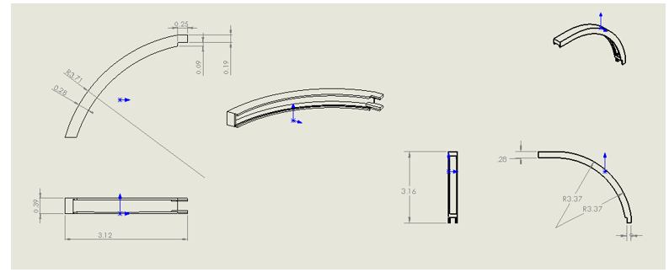
Figure 19 Final headset support designs. The left support is for the left and right part of the headpiece while the right support is for the back part of the headpiece.
Figure 15 shows a Solidworksi assembly of the final headset prototype on a human model. There are now more points of contact of the headpiece on the sides and the back of the head since cushioning will not be needed anymore. Figure 16 shows an exploded view of the assembly of the final headset design, as well as a close up view of the slot mechanism to show how the supports will be attached and secured to the headpiece.
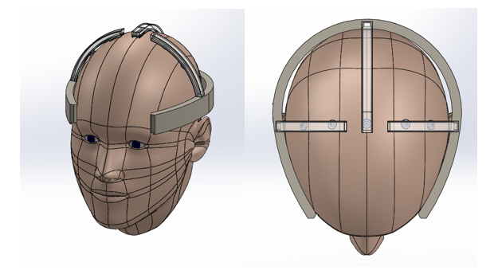
Figure 20 Solidworks assembly of final headset prototype on a human head model with electrodes.
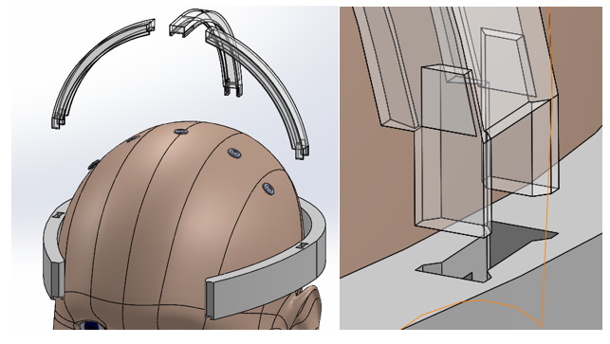
Figure 21 Solidworks exploded assembly of final headset design on human head model (left). Close up view of slot mechanism of the support and headpiece (right).

Stress analysis was performed in Solidworksi to ensure that the final headset design is durable enough not to bend and fracture beyond normal force applications. It was performed on the sides of the headpiece of the headset as seen in Figure 17 at 60 N to account for an individual pulling the headset to wrap around the head and the bottom part of the support at 10 N as seen in Figure 18 to account for the head applying a force if the support is tightly placed on the head. It is noted that the stress analysis was performed without the bottom attachments for the headpiece and electrode supports.
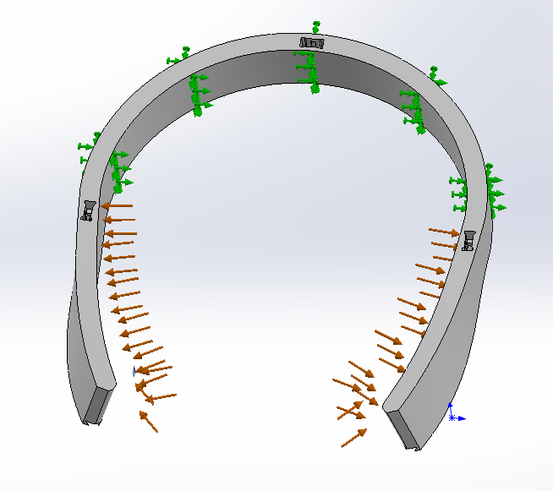
Figure 22 Stress analysis test on final design headpiece using 60N force at the inner sides.

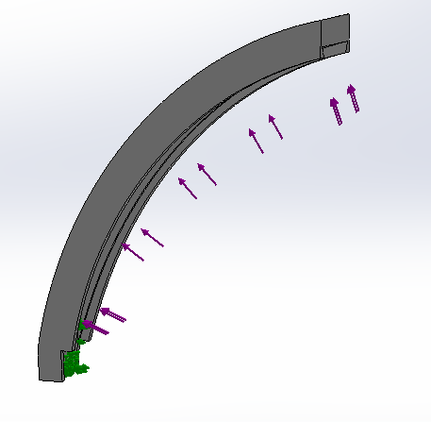
Figure 23 Stress analysis test on final design support using 10 N force applied at the bottom
Looking at the mass properties of the headset on Solidworksi, it is estimated that it will cost about $100 - $125 per print. A budget of $600 will be used to account for additional prints to improve the design even further. Not all of the money will be necessarily used. It is set to avoid any chance of going over budget when 3D printing the headset.
The final headset design will be approved and tweaked by the end of the semester after receiving feedback from faculty. It is planned to be 3D printed during Winter break, and put together with the circuit components and the battery and circuit casing during the early part of the Spring semester.

Chapter 7: Conclusion
The Epileptic Monitoring Device will be judged based on its efficiency, effectiveness, low cost, and ease of use. If the device is not efficient, then it will fail to be long lasting. A non-mobile application would make it no different from any other device on the market. The customer should not be limited to what they can and cannot do when utilizing the EMD. The comfort of the user should be a number one priority for this device.
The effectiveness is determined by how well it can characterize seizure like signals. If the device fails to do so, then the device fails as a whole. It must be able to characterize a signal as non-epileptic, epileptic, or non-determinant. The non-determinant area will be the grey area where a person would have to consult their doctor or physician for more information. If the device should fail to characterize properly, then it would be unusable by the customer.
A higher costing product would deter anyone from purchasing it. The EMD needs to make a person’s life easier, and it cannot do so if the product is too expensive. There should not be any unnecessary products that would drive up the cost. The device will only be successful if it can assist as many people as possible.
It cannot be assumed that the general customer would be able to understand all aspects of this device. That means if the product is not easy or manageable, then the device will fail to reach the majority of the population that would otherwise purchase the device. Anyone should be able to put on the EMD and have it work properly.

Appendix

Team Members

Engineering Standards
ISO 10993-10:2010: Biological evaluation of medical devices – Part 10: Tests for irritation and skin sensitization
Applies to design due to the interaction between the electrodes, conductive solution, and the scalp.
ISO/TS 11073-92001:2007: Health informatics – medical waveform format – Part 92001: encoding rules
Applies to design because the EEG waveform will be displayed on android application
ISO/TR 21730:2007: Health informatics – use of mobile wireless communication and computing technology in healthcare facilities – recommendations for electromagnetic compatibility (management of unintentional electromagnetic interference) with medical devices
Applies to design because the headset and android application are connected wirelessly using Bluetooth.
ISO/TR 21548:2010(en) Health informatics – security requirements for archiving of electronic health records – guidelines
Applies to design because the EEG readings are stored and are electronic health data files

Realistic Constraints
Manufacturability: The design of the device takes into consideration the items that we use every day in order to ensure a successful integration into one’s life. For example, the software that works in hand with the electrodes on the headset with analyzing the recorded EEG waves will be used on an android smartphone, a device that is more than capable of performing all of the necessary tasks to characterize and display the results that we need. This allows us to take advantage of the ubiquitous presence of smartphones, something that is commonplace nowadays, to use in conjunction with the headset, allowing for a reduction in cost because this eliminates the need to create a completely separate device to handle the computing and characterization of the EEG data.
Social: The device needs to be aesthetically pleasing and comfortable for the user to wear throughout the day in order to not have his or his activities hindered. The device will be accessible to those who are undergoing treatment for epileptic seizures. It is designed to passively record EEG waves without interfering with the everyday activities of the patient. There are no cultural norms that may limit the use of the device; however, the social norm of taking a hat off when inside a building such as a school may impact the design. In the end, it probably will not have too much of an impact.
Political: The manufacturing and use of our device will solely rely on the resources on American soil. The product is not designed to cause any controversy. It’s designed to assist not only the patient, but also the caretaker and physician as to be able to know when an epileptic seizure took place, and what the EEG data was for a physician to analyze. Any political influence would primarily be from healthcare professionals who may downplay the accuracy and/or reliability of the product. Our response to such influence would be that we only plan on providing aid to those in need and encourage constructive criticism to make our product better.
Economical: This device is designed to be a low cost option for patients experiencing neurological abnormalities. We should be able to create our device well within the budget of $600. If the device is manufactured on a larger scale the material costs will lower significantly. In terms of manufacturing the device, it may require a significant attention to detail which may increase the amount of time it takes to produce a single device. The intended market and user of the device are individuals experiencing seizures who aim to further track their seizure-like activity beyond the confines of a clinical setting.
Environmental: There will be only one resource used in the creation of this device that would be environmental concerns. The main parts of the device include a microprocessor (from the smartphone and arduino board), signal amplification, headset, electrodes, and rechargeable batteries. The batteries being used are rechargeable lithium ion batteries. These batteries should be disposed at the user’s local battery recycling center.
Sustainability: The device will use reusable electrodes, thus reducing the environmental impact compared to using disposable electrodes. The design for the headset also is created to be used repeatedly and has no parts which would require replacement over time. All of the resources which will be used in this device are all readily available and renewable since majority are electrical components. The manufacturing of the device should be fairly simple and should employ sustainable manufacturing techniques.
Health / Safety: The device is safe for use because it is simply recording the EEG and is only sending electrical signals from the electrodes to the signal processing apparatus and not in the opposite direction. To ensure that the patient will be safe, bio isolation amplifiers, which acts as a reversed diode, will be used and the Arduino board has over current and reverse polarity protection features. There are no hazardous materials used in the manufacturing of the device and will not pose a health risk to workers assembling it. The device also will not have any materials, which are hazardous to the user. The user will however need to ensure proper techniques are used to apply the electrodes to the appropriate locations.

Engineering Tools
Tool | Description
P-spice | Circuit modeling
Matlab | FFT and graphing EEG signals
Oscilloscope | Used to validate working design circuit
Java | Coding to develop android application
Multimeter | Used to read current/voltage
Wave form generator | Provides signal and power
Bluetooth module | Receives digital EEG data wirelessly to send to the Android application
Arduino pro mini board | Microprocessor that performs analog to digital conversion to send to Android application via Bluetooth
EEG electrodes | Used for measuring and recording EEG data from the scalp
Solidworks^{i} | Used for modeling the EEG headset with electrodes on a human head model and for stress testing
3D printing | Prints out solidworksi model of the headset design
Emotive headset | Used for recording EEG data from each of the team members and as a source for the fundamental headset design
FTDI basic breakout 5V (sparkplug) | Used to program arduino pro mini board
Breadboard | Used to build the circuit for amplification and filtering
Bio amplifier | Amplifies EEG signal, makes sure none of the voltage goes back into the EEG
Android tablet and application | Used to display EEG waveforms and process and store data
Figure 24: Table of engineering tools used for the EMD

Ethical Concerns
The device is non invasive, so it will not cause any pain or harm to the patient using the device. Protective measures are being implemented within the project to ensure safety for the user. For example, bio isolation amplifiers are being used and the Arduino board has over current and reverse polarity protection features. Human testing will be required to make sure the device is functioning properly. An IRB application will be filled out in order to be able to legally test ourselves and other humans for data. The design will not use any human source material. The device will be made from polymer using the 3D printer. This device is morally and ethically acceptable to anyone. All the device wishes to accomplish is to display the EEG signals from a user’s brain and record data if needed.

IRB
Rachel & Kevin

Gantt chart
Figure 25: Gantt chart close-up of time-line
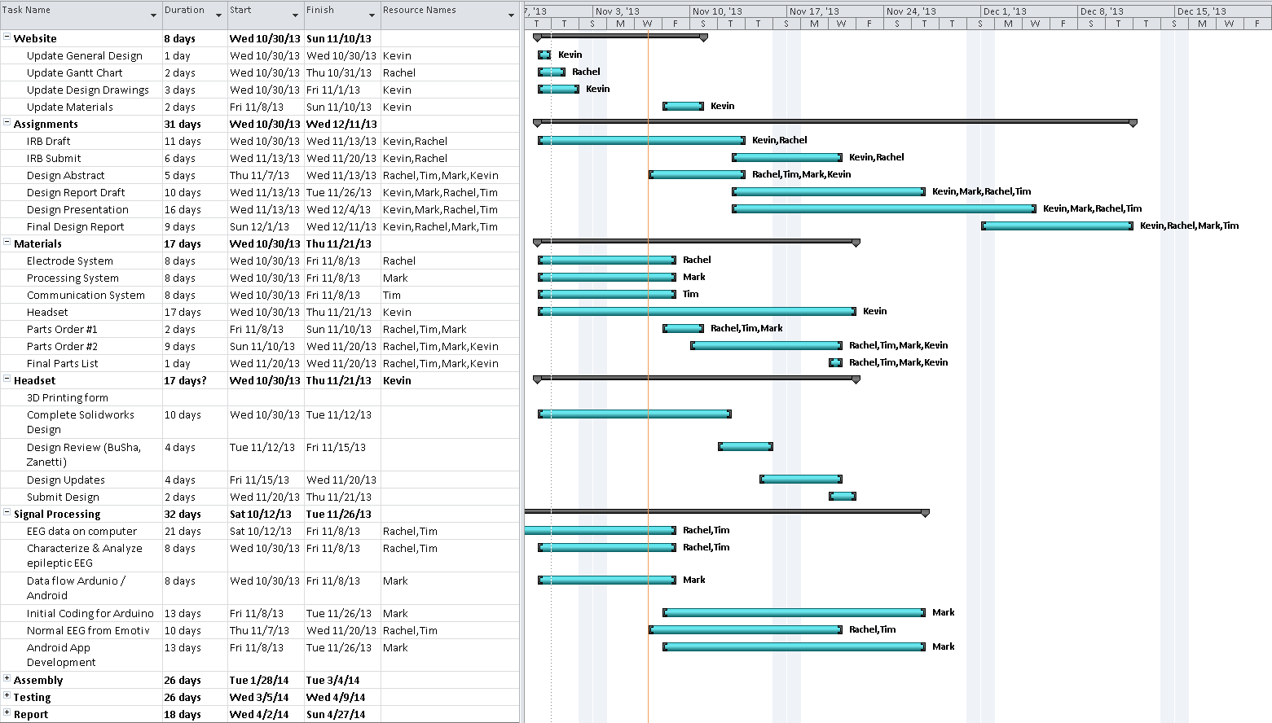
Figure 26: Gantt chart overview of timeline

Materials List
Name | Description | Quantity
Bluetooth transceiver | Wirelessly transmits signals between arduino microcontroller and android application | 1
Isolation Amplifier | Provides electrical isolation and is a safety barrier between the electrodes attached to the patient and the power source and arduino microcontroller | 4
Non-Inverting Amplifiers | Used for the low-pass filter design to increase the gain | 4
Polymer Lithium Ion Battery | Provides voltage to shift the values of the EEG signals from negative to positive, and powers the ardunio & Bluetooth transceiver | 2
Polymer Lithium ion Battery Charger | Charges the battery | 2
Gold Cup Electrodes | Detect the electrical current from the brain on the scalp | 5
Electrode Foam and Holders | Attaches to the electrode to hold conductive solution to enhance electrode readings | 5
Nexus 7 -2013 | Android tablet to run application on | 1
Pro Mini Arduino Board | Analog-to-digital conversion of signal from electrodes | 1
VeroBlue Polymer | Rigid opaque polymer that the headset will be made out of using the 3D printer | 400 g
Emotiv Headset & Software | Used to obtain non-epileptic EEG readings to compare EMD to | 1
Foam cushioning and padding | Placed on the headset to make it more comfortable for the user | 5 g
Figure 27 Materials list for the EMD

Project Budget
Part | Amount
Signal Processing | $96.33
- Bluetooth Module | $15.99
- Bio amplifier | $30.00
- Polymer Lithium Ion battery | 29.35
- Charger | $20.99
Electrodes+ accessories | $100.00
- Electrodes (with shipping) | $74.95
- Foam and holders (with shipping) | $25.05
Headset Materials and Printing | $600.00
Digital Processing | $264.95
- Android Tablet | $250.00
- Arduino Board (with shipping) | $14.95
Poster Board (for next semester) | $25.00
Total | $1086.28
Funds Available | $400.00
Additional Funds needed: | $686.28
Figure 28: EMD Budget Overview

Business Plan
Our business aims to provide epileptic patients with a reliable, portable, comfortable, and easy to use EEG monitoring device. By using the least amount of electrodes, and placing the device inside a skull cap, patients will be able to wear the device anywhere they please. Current devices are not portable, and they can only be monitored inside a hospital. Our device will record EEG waves from the scalp, store the information, and warn a caretaker in the event of a seizure. We want the customer to feel comfortable without having to draw attention to themselves while they are out. Our team’s philosophy is about placing the customer above ourselves by giving them the best care at our disposal. We care about the customer. Profit is the least of our concern. The greatest accomplishment that we can achieve as a company is knowing that our customers are satisfied with the success our product. We want our product to accurately and effectively collect data to display to the user and healthcare professionals. If our customers can have a piece of mind from our product then we have done our jobs. But being satisfied only lasts for so long. We want our customers to send us feedback so that we can constantly improve our product to meet the needs of the user. Our success is measured by how effective, easy to use, and comfortable the device is. The effectiveness is measured by several factors. The device must be able to read EEG signals, store them, and tell whether or not they are comparable to seizure like signals. Any time delay must be taken into account, and the longer the delay, the less effective the device is. It must also have a long battery life, and be able to send warning alarms to a caretaker in the event of a seizure. Any delays, or failures, on this part would be extremely detrimental to our product.
Our goal is to make a device with less than 8 electrodes needed. Any more, and it will become too time consuming for the customer to put on in the morning. We want everyone to be able to situate the electrodes by themselves in order to keep the device portable. Having a doctor or nurse place the electrodes would defeat the point of our device. We don’t want our customers to suffer while using our product. A big and bulky EEG would deter people from properly using it. We want our customers to be able to walk around in public without getting stares or drawing attention. The more comfortable they are wearing the device, the better we will feel about it. The Epileptic Monitoring Device team does not want this to affect anyone’s daily routines.
There are several reasons that distinguish us as a company from the others. The main reason is that there isn’t a product on the market like ours that allows consistent data reading/storing masked by a fashionable design. Our product does not require lumps of cash from the customer’s pockets because our product is low cost. Our product has very efficient due to it’s low power capabilities. It is a over-the-counter product that eliminates the need to hassle with insurance companies.
In order to develop our new company, we would need to market the device to a venture capital firm who would want to invest in us. There is a list of biomedical engineering firms that would invest in new bioengineering technology. Biotechnology is one of the biggest areas these firms will support and buy into. Our goal would be to market to them, and receive enough funding to fine tune the device. Depending on it’s popularity, we would then look to sell the device to a company that would be able to mass produce it. The venture capital firm would then receive some of the profits for initial funding.

Citations

“Solidworks”. Dassault Systems. Web.
Lee, Jin-hee, Su-jeong Hwang Shin, and Cynthia L. Istook. "Analysis of Human Head Shapes in the United States." Apparel Design & Manufacturing Classes. Texas Tech University, 12 June 2006. Web. 25 Nov. 2013.
“Objet30 Pro” Stratasys. Web.
"10 20 System Positioning Manual." 10 20 System Positioning. Trans Cranial Technologies, 2012. Web. 26 Nov. 2013. <http://www.trans-cranial.com/local/manuals/10_20_pos_man_v1_0_pdf.pdf>.
"Guideline 6: A Proposal for Standard Montages to Be Used in Clinical EEG." American Clinical Neurophysiology Society. American Clinical Neurophysiology Society, 2006. Web. 26 Nov. 2013. <http://www.acns.org/pdf/guidelines/Guideline-6.pdf>.
Oxley, J., and M. Roberts. "Clinical Evaluation of 4-channel Ambulatory EEG Monitoring in the Management of Patients with Epilepsy." Journal of Neurology, Neurosurgery & Psychiatry 48.9 (1985): 930-32. Print.
Tallgren, P., S. Vanhatalo, and K. Kaila. "Evaluation of Commercially Available Electrodes and Gels for Recording of Slow EEG Potentials." Elsevier Science Direct. Clinical Neurophysiology, Apr. 2005. Web.
Niedermeyer, Ernst. "The Normal EEG of the Waking Adult." Electroencephalography: Basic Principles, Clinical Applications, and Related Fields. Lippincott Williams & Wilkins, 1999. Web. 25 Nov. 2013. <http://www.ccs.fau.edu/~bressler/EDU/NSP/References/Niedermeyer_1999.pdf>.
Repovš, G. "Dealing with Noise in EEG Recording and Data Analysis." Research Review Paper. Informatica Medica Slovenica, 2010. Web. 25 Nov. 2013. <http://ims.mf.uni-lj.si/archive/15(1)/21.pdf>.
Vaisanen, Outi. "Multichannel EEG Methods to Improve the Spatial Resolution of Cortical Potential Distribution and the Signal Quality of Deep Brain Sources." Tampere University of Technology, 13 June 2008. Web.
Bohorquez, Davies P.J. "Design of a Portable Wireless EEG System Using a Fully Integrated Analog Front End." IEEE Xplore. Southern Biomedical Engineering Conference, 3 May 2013. Web. 26 Nov. 2013.
http://eegatlas-online.com/index.php/montages
"Guideline Twelve: Guidelines for Long-Term Monitoring for Epilepsy." American Clinical Neurophysiology Society, 2008. Web. <http://www.acns.org/pdf/guidelines/Guideline-12.pdf>.
"BioSemi Headcaps." BioSemi Headcaps. N.p., n.d. Web. 26 Nov. 2013. <http://www.biosemi.com/headcap.htm>.
"What Is Montage Type of TestBench EEG Data?" Emotiv Community Forums. Emotiv, 11 Jan. 2011. Web. 26 Nov. 2013. <http://emotiv.com/ideas/forum/forum12/topic2507/>.
"Introduction to EEG and MEG." Cognition and Brain Sciences Unit. MRC, n.d. Web. 26 Nov. 2013. <http://imaging.mrc-cbu.cam.ac.uk/meg/IntroEEGMEG>
Van Den Broek, S.P., and F. Reinders. "Volume Conduction Effects in EEG and MEG."ScienceDirect. Electroencephalography and Clinical Neurophysiology, n.d. Web. 26 Nov. 2013.
http://conorrussomanno.me/2012/06/19/interactive-android-application-for-eeg-biofeedback
Chi, Y.M., and Yu-Te Wang. "Dry and Noncontact EEG Sensors for Mobile Brain–Computer Interfaces." IEEE Xplore. Neural Systems and Rehabilitation Engineering, Mar. 2012. Web. 26 Nov. 2013.
"G.SAHARA Active Dry Electrode System." G.SAHARA. G.tec Medical Engineering, n.d. Web. 26 Nov. 2013. <http://www.gtec.at/Products/Electrodes-and-Sensors/g.SAHARA-Specs-Features>.
"EPOC Neuroheadset." Emotiv Neurotechnology. Emotiv, n.d. Web. 25 Nov. 2013. <http://www.emotiv.com/store/hardware/epoc-bci/epoc-neuroheadset/>.
Noras, Maciej A. "Voltage Level Shifting." TREK INC. Trek Application Note, 2013. Web. 25 Nov. 2013. <http://www.trekinc.com/pdf/6001_Voltage_Level_Shifting.PDF>.
"The Comparison of Wi-Fi, Bluetooth and ZigBee." Sena Blog. M2M Solutions Provider, 25 Feb. 2010. Web. 25 Nov. 2013. <http://www.sena.com/blog/?p=359>.
"Arduino Wireless Bluetooth Transceiver Module Slave 4Pin Serial + DuPont Cable."Amazon.com. Amazon, n.d. Web. 25 Nov. 2013. <http://www.amazon.com/Arduino-Wireless-Bluetooth-Transceiver-Module/dp/B0093XAV4U/ref=cm_cr_pr_product_top>.
Andrzejak RG, Schindler K, Rummel C (2012). Nonrandomness, nonlinear dependence, and nonstationarity of electroencephalographic recordings from epilepsy patients. Phys. Rev. E, 86, 046206
"EPOC Neuroheadset." Emotiv Neurotechnology. Emotiv, n.d. Web. 25 Nov. 2013. <http://www.emotiv.com/store/hardware/epoc-bci/epoc-neuroheadset/>.
"Emotiv EPOC Specifications." EPOC Specifications. Emotiv, 2012. Web. 25 Nov. 2013. <http://www.emotiv.com/upload/manual/sdk/EPOCSpecifications.pdf>.
Smith, S. J M. "EEG in the Diagnosis, Classification, and Management of Patients with Epilepsy." Journal of Neurology, Neurosurgery, and Psychiatry. BMJ Group Journals, 2010. Web. 25 Nov. 2013.
"Arduino - HomePage." Arduino - HomePage. Arduino, n.d. Web. 25 Nov. 2013.
"Wiring." Wiring - HomePage. Wiring, n.d. Web. 25 Nov. 2013.
"Processing2." Processing2 HomePage. Processing, n.d. Web. 25 Nov. 2013.
"Arduino - Introduction." Arduino - Introduction. Arduino, n.d. Web. 25 Nov. 2013.
"Android Homepage." Android Homepage. Android, n.d. Web. 24 Nov. 2013.
McCracken, Harry. "Who’s Winning, IOS or Android? All the Numbers, All in One Place | TIME.com." Technologizer. Time Tech, 16 Apr. 2013. Web. 24 Nov. 2013.
Souppouris, Aaron. "Android 4.4 KitKat Coming to Nexus 7 and 10 Starting Today."The Verge. VOX Media, 13 Nov. 2013. Web. 25 Nov. 2013. <http://www.theverge.com/2013/11/13/5098776/android-4-4-kitkat-nexus-7-10-4-update-schedule>.
Ionescu, Daniel. "Bluetooth 4.0 Becomes 'Smart': What It Means For You." PCWorld. PCWorld, 25 Oct. 2011. Web. 25 Nov. 2013. <http://www.pcworld.com/article/242517/bluetooth_4_0_becomes_smart_what_it_means_for_you.html>.
“Biosemi” Products-Headcaps. Web.
Gorman, Michael. “Axio's EEG headband helps you teach your brain to focus (hands-on)”. Engadget. Web.
“Rigid Opaque” Stratasys. Web.
“Zygote Solid Human Head” 3D Content Central. Zygote Media Group. Web. 02 Feb. 2011.

